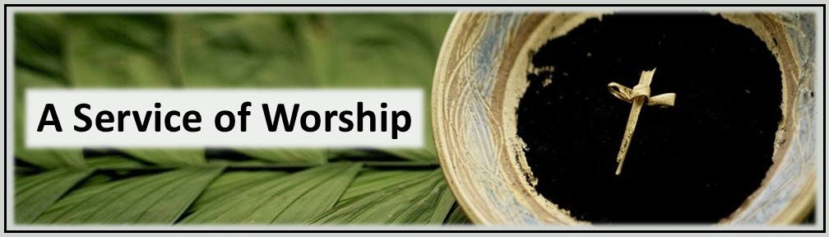
PRELUDE

WELCOME AND ANNOUNCEMENTS
† CALL TO WORSHIP
Leader In the beginning, God formed humankind from the dust of the ground.
People We come from the dust, and to the dust, we shall return.
Leader God breathed into us the breath of life.
People We are dust. Yet, we live by the breath of God.
Leader When we forget who we are, when we lose our way, when we find ourselves bent beneath the weight of sin and shame,
People Christ comes near, not to condemn, but to restore.
Leader He kneels in the dust beside us. He meets us in our humanity.
People We worship the one who forms us, redeems us, and breathes new life into us again and again.
ALL Let us worship God.

†PRAYER OF INVOCATION

†HYMN # 202 Amazing Grace

CALL TO CONFESSION

PRAYER OF CONFESSION
Merciful God,
You formed us from the dust of the earth and breathed into us the breath of life, yet we have forgotten who we are. We have turned away from you and trusted in our own strength. Time and again, we have sinned in thought, word, and deed. We have remained silent when we were called to speak. We have failed to act in the face of injustice and oppression. We have been quick to judge others while ignoring the sin within our own hearts. We confess that we cannot save ourselves. We need your mercy and forgiveness. Draw near to us again, O Lord. Kneel beside us, and touch the dust of our lives with your grace. Amen.

ASSURANCE OF PARDON

PASSING OF THE PEACE
SCRIPTURE LESSON Genesis 2:4-9 John 7:53-John 8:1-11
SERMON Written in Dust Amanda Shanks
THE IMPOSITION OF ASHES Introduction
Prayer over the Ashes
Reception of Ashes
Concluding Prayer

†HYMN # 448 A Charge to Keep I Have

BENEDICTION

POSTLUDE
†All who are able are invited to stand

